One Stop Solutions,

Business Plan.



Date: January 1st 2019

Jason Smith x17702485
Muhammad Abu Bakar Sani x17112044
Umer Iqbal x17111854
Mark O Kelly x17742461
Aviendha O Broin x17500536

One Stop Solutions,
Business Plan.

CONTENTS:

SECTION 1 EXECUTIVE SUMMARY.

SECTION 2 INTRODUCTION.

SECTION 3 MARKET.
Overview
Trend
Size and potential
Competition
Customers
Structure
S.W.O.T. Analysis

SECTION 4 MARKET STRATEGY.
Objectives
Product
Price
Place
Promotion

SECTION 5 ORGANISATION / MANAGEMENT.
Management Overview
Staff Requirement

SECTION 6 PRODUCTION AND OPERATIONS.
Premises
Plant and Equipment
Operations Overview

SECTION 7 COSTINGS & FINANCE
Financial Assumptions
Sensitivity Analysis

APPENDICES :
Appendix A Financial Projections - Yr.1 and Yr.2
Profit and Loss; Cash flow
Balance Sheet
Appendix B Promoters’ C.V’s.
Appendix C Typical Product Drawings

SECTION No. 1

EXECUTIVE SUMMARY.

Company Name : One Stop Solutions.,

Address : 7 Westpoint Business Park,
Mulhuddart
Dublin 15.

Telephone : 01- 560 0000
Fax : 01- 560 0001

Co. Registration No.: 119876XXX

V.A.T. No.: IE 200350003E

Accountants : Joe Kelly, ACCA
Business Park,
Dublin 2.

Bank: Eire Bank,
Bank Centre,

One Stop Solutions is a Company recently formed by the five promoters - J. Smith, M. Abu Bakar, U. Iqbal, M. O’Kelly and A. O Broin - to fulfil an identified market in Irelands growing software development industry.

The company’s objectives into the future are:
- To achieve a profitability of 5 % return on sales by year 1.
- To achieve a 29 % share of the identified market by the end of year 2.
- To achieve a profitability of 15 % return on sales by year 2.
- To secure ISO 27001 accreditation in the short term and be GDPR ready.
- Medium Term - to buy its own premises in the Dublin area.

This Business Plan is produced with a view to securing the necessary investment from :
Bank :
Term Loan € 80,000
Overdraft Facility € 10,000
County Enterprise Board € 13,505
TFI upfront payment € 35,000

SECTION No. 2

INTRODUCTION

OVERVIEW.
One Stop Solutions is a recently formed company aiming to engage in software development, primarily serving the Irish software market.

The promoters have identified a niche in the transport sector of the mobile phone application industry for the manufacture, maintenance and supply of a mobile phone application which combines all four of the Transport for Ireland services into one easy to use application.

Coming from the technology sector and also all being frequent users of the public transport system, the promoters were inspired to undertake this project. This is because they felt the need to provide reliable real-time information for all of the public transport services in one, simple to use mobile application.

Mobile applications such as these are currently supplied on the Google Play Store and the Apple App Store. They are developed by independent developers and also by small software development companies. The problem is that there is a separate mobile application for each transport service. So end users need to download a Dublin Bus, Luas, Dublin Bikes and Irish Rail application for each of these services to get real time schedule information for them. With the One Stop Travel application the end user can get all of this information from one simple to use application instead of four. This provides a much better experience to the end user and also greatly enhances each of the different transport services.

In view of the foregoing One Stop Solutions. have put together a competent team and this business plan in order to respond to the demand.

The type of work typically undertaken will comprise:
- Software development,
- Mobile applications development,
- Web application development
- Graphic design
We aim to be a one stop solution for all software development needs

GRANT ASSISTANCE.
It is intended to seek financial assistance from the County Enterprise Board in the form of Capital Grants in the amount of €13,505 for equipment as scheduled herein which will assist in the operational set-up required and provide jobs to meet with the objectives of this business plan. Initial approaches to the C.E.B. have been made and indications are that they are willing to back the project, as it represents an investment of only €2,701 per job. (5 jobs total).
MARKETING
The Market

One Stop Solutions will operate in a specialised niche market within the Software development Industry. Our flagship product will be our One Stop Travel App.

Overview
The download market statistics for mobile phone applications on the Android platform in Ireland is shown in the table hereunder:
Mobile phone public transport applications.
(excluding Apple IOS, which do not publish data..)
Installs
Dublin Bus (Official) 300,000+
Dublin Bus Next Dublin Bus (Free) 100,000+
Luas (Official) 100,000+
Real Time Ireland 100,000+
Journey Planner 100,000+
Iarnrod Eireann Rail App 100,000+
All Bikes Now 100,000+
-----
Full list included in the Appendices.** 1,090,000 Installs **

**Source: Google Play Store, 2019

93% of Irish consumers now own or have access to a smartphone. The growth among the age 65+ market grew 13% in 2017 - 2018 alone. (Deloitte 2019)

Our research shows that the Android platform accounts for 50.17% of the Irish Market and IOS takes 49.49%. There have been over 1,090,000 downloads of all four types of public transport apps for the Android platform alone. Apple do not publish their stats but it is reasonable to assume that this figure is similar on the IOS platform due to their market share being almost identical. (GS Statcounter 2019)

Our target is to get 350,000 or just 29% of these downloads on the Android platform in year 1 and the same for the IOS platform which we will develop in year 2. We also expect a strong take up of the app going forward as it gains in popularity.

Market Trend

Ireland is the worlds second largest software exporter. Average wages in the software sector rose up by 11.4% since the 2011, almost double the growth rate of 4.3% in the overall Irish labour market.
Our company will be able to deal with following languages: -
- Git
- jQuery
- Xml
- Json
- HTML 5
- Java
- Java Script
- SQL

Size and potential
Ireland is providing its major role in computing industry. LinkedIn says, there are over 900 software companies, including both multinational and indigenous firms, employing 24,000 people and generating € 16 billions of exports annually. So, there is huge market and great competition between companies and candidates.
Around 70% of the total population of Dublin is using public transport to go to offices or colleges. There is a huge market for ONE STOP TRAVEL APP because it will save their time, phone space and reduce hassle for them to switch from one transport type to another.

Competition

The competition in this market comes from other mobile application developers. Commutable are a software company that provide transport information through their popular “HitTheRoad.ie” website. They do not produce a mobile application yet. They also do not provide information on Dublin bikes, but they could turn their attention to these services in the future

Customers
Our flagship product will be the One Stop Travel application which we are developing for Transport for Ireland. We also aim to develop other applications for other organisations in Ireland. We are currently in talks with the Vegan Society of Ireland to develop an application to help their customers organise meal plans and monitor calorie intake and nutritional information. We are also working on a prototype for a One Stop Fitness app for Ben Dunne Fitness which will help their members plan exercise workouts and organise fitness plans.

List of Target Customers:

- Transport for Ireland (TFI)
- The Vegan Society of Ireland
- Ben Dunnes Fitness

S.W.O.T. Analysis

STRENGTHS
The promoters have a solid background within the technology industry and have been encouraged by the level of support which they have received from the major developers and software manufacturers. Since reputation within the industry is extremely important this will contribute greatly to securing new customers, in line with our planned projects.

The company enjoys a favourable location situated on the site of one of the largest industrial sites in Dublin close to the N3 motorway. The promoters have a proven track record in their ability to produce, on time and to budget the specialist products as required by our customers and recognise the importance of meeting deadlines within the overall context of construction projects.

WEAKNESSES

Financial resources are limited during the early stages, but this Business Plan details the requirements and sources from which it is anticipated funding, in addition to the promoters’ input, will be forthcoming. As a result of which the company will be adequately funded to meet the requirement of the objectives as detailed elsewhere in this submission.

OPPORTUNITIES
While the immediate plan to achieve targets as identified is confined to developing the application for the Android platform. We will also begin development of the application for the Apple IOS platform which we hope to release for the start of the second year. This will double the amount of downloads because the IOS platform is almost identical in size to the Android platform.

Once the application is established across both platforms it is the company’s medium term goal to develop more software applications for companies in other industries that we are currently in negotiations with. We will also seek to use the OST application to showcase our skills and seek expand and to develop similar transport applications for other transport authorities in other European cities.

THREATS
The single greatest threat to the company is that of opportunity loss in terms of the extent of business being lost due to our current non-trading. This results in orders being lost to smaller competitors who are being afforded the business, thereby becoming larger and greater competition.
MARKET STRATEGY

In order to achieve our Sales Target as per the enclosed projections the following strategy has been devised :

Objectives.
- To achieve a profitability of 5 % return on sales by year 1.
- To achieve a 29 % share of the identified market by the end of year 2.
- To achieve a profitability of 15 % return on sales by year 2.
- To secure ISO 27001 accreditation in the short term and become GDPR ready.
- Medium Term - to buy its own premises in the Dublin area.

Product.
OST stands for One Stop Travel. This mobile application will combine the separate Dublin Bus, Luas, Irish Rail and Dublin Bikes applications into one single mobile application.

This application will provide reliable real time information of all the transport services listed above.

Our main target users are:

- Commuters who use public transport. For example, those who use public transport to go to offices, schools and colleges every day.
- Tourists visiting Dublin who don’t have enough information about public transport, will find info about four different types of public transport in one place.

OST is currently the only mobile application which provides information for all four of the transport services in the one this is what makes it unique compared to other applications.

Price.
Public transport apps are usually available for free to the public who do not expect to pay for them. They do provide value to the transport authority and greatly enhance their services. So, we will not sell to the public but instead we will lease the app to TFI in a supply and maintenance contract. We will charge an up-front fee of €35,000 on an annual basis and also a commission of €0.30+VAT per download. In return we will supply, develop, update and maintain the application. This will also resolve the poor reliability and quality issues that affected previous attempts to combine public transport applications.

Place.
The largest two mobile OS platforms in Ireland are Android 50.17% and IOS 49.49%. (GS Statcounter 2019) Mobile applications are sold for these platforms through Google Play Store and Apples App Store. We decided to develop the OST application first for Googles Play Store. This is because the Android platform is much cheaper and easier to publish in. We will also start developing the OST application for the Apple IOS platform which we hope to have available for the start of year 2. The IOS version will be published on the Apple App store where we predict a similar download rate to the Android platform. The popularity of both platforms provide access to a huge potential market. Our research has shown almost 1.2 million downloads of different Irish public transport applications from Googles Play Store alone.

We will develop the OST application in our rented office space in West Point Business Park in Dublin. Our medium-term goal is to expand the software business and develop more applications. This will require us to hire more staff and move to a larger and more suitable premises closer to Dublin City Centre.

Promotion.
Most of the company’s revenue will come from commission on each download of the application. For this reason, it is important that the application is promoted properly. We have allocated a total of €70,000 for advertising (€35,000 for each year). We will promote the application using social media platforms such as Facebook and Twitter. We will also heavily promote the application in schools, colleges and universities to staff and students who are frequent users of public transport.

We will also look to form an advertising partnership with TFI to promote the application through advertising on their transport services. This makes perfect sense for both parties because the application will greatly enhance the Transport services of TFI and the commuters who use these transport services are the people who we are targeting to download the application.

So we will propose an agreement where we will cover the cost of promoting the application on radio, social media and also in colleges and universities while TFI provide advertising on each of their transport services for a limited time to help to insure a quick take up of the application.

ORGANISATION/ MANAGEMENT

The Organisation
One Stop Solutions is a partnership with all of the shares owned in equal measure by the five promoters. A copy of the Certificate of Incorporation is appended, and a copy of the Memorandum and Articles of Association will be made available to the Bank in the normal course.

Management Overview
Key Staff and their activities.

The combined expertise of the primary promoters has allowed for a ‘natural’ division of responsibilities as detailed hereunder:

M. Abu Bakar Sani Chief Executive Officer

10 Years Software development experience
BA in Business Management from UCD.
BSc in Computing (Honours) from NCI.
Software Development

J. Smith, Chief Financial Officer

Assistant Manager in Oracle Software Group
BA (Hons) Accounting & Finance from DBS
BSc (Honours) in Computing from NCI
Graphic Design

U. Iqbal, Marketing Manager.

10 years experience in Software industry (Project Management)
MSc in Software Development from NCI
BSc (HONS) in computing from NCI
Software Development

M. O’Kelly, Chief Operating Officer.

10 years’ experience in Software industry (Project Management)
BA in Business Management from UCD.
BSc in Computing (Honours) from NCI.
Junior Software Developer

A. O Broin, Head of Human Resources

8 years’ experience in Software industry (Project Management)
BA in Business Management from UCD.
BSc in Computing (Honours) from NCI.
Graphic Design

Full Curricula Vitae for the promoters are included in the Appendices.

Staff Requirement.

Year 1 Year 2

Developers 2 2

Designers 2 2

Junior Developers 1 1

0 0

------- ------
Total: 5 5

All five staff members are also equal shareholders in the business and will work in house on the software development projects project for the first two years.

After the first two years we will seek to hire additional staff based on the performance of the business. New staff additions will be recruited and will be required to participate in on-the-job training and to take part in the national college internship. It is intended to offer permanent positions to suitable apprentices on completion of their training.

PRODUCTION AND OPERATIONS

Premises:

One Stop Solutions will begin operation within the Industrial Estate, West Point Business Park, Mulhuddart Dublin 15.

This location comprises 160 sq. ft. has the sufficient capacity for the team and for our plans as mentioned before and will be sufficient for the short term.

For our medium-term goal of our Company is (3 years.) to purchase a bigger premise closer to Dublin city centre.

The current office for our work place requires capital for improvement in terms of heating, lighting, office furniture and canteen accommodation. With the company’s eagerness to own their own premise in the medium term.

A fire exit door and fire hydrant will be available and within reach for team members in the Office.

The required expenditure capital is included in the financial projections appended.

Health & Safety/ Employment and Tax Legislation.
The promoters are aware of the provisions of the Health, Safety and Welfare at Work Act, 1989 and of any hazards present within a facility such as proposed above. Promotors will prepare a Safety Statement which will be implemented and ensure safe working practices and environment for the working staff.

The many provisions under the Employment Legislation, Working Time Directive and so on. Are known to the promotors and the company will adhere to them. Every employee will be handed a contract of employment when recruited and the proper tax returns and books will be maintained.

Insurances.
The promotors have taken the advice on the required insurance provisions as necessary. Items like Employer Liability, fire, public Liability and any perils insurance and so on. Are covered and costed in the projected financial Statements as appended.

Premises and Equipment.
The office will be fitted out with the following plant and equipment:

1No. 5 Windows 10 computers
2No. 1 Printer
3No. 5 Working desks
4No. Server
5No. Switch
6No. 1 Scanner
7No. 7 Adjustable chairs

Production/Operations
The sequence of steps leading to a finished product and ensuring that it is fully functional and ready for consumers use.

We test our applications for compatibility on mobile devices on each platform and on different models of phones. We then test the user interface for any errors. Android studio allows us to connect our own mobile devices to test the interface as well. This is followed by more tests and a report at the end.

Customer service will be headed by one of the team members whose job will be to help customers with any problems they have in understanding the application.

Further product improvements will be made to accustom people who are colour blind. Other improvements will be made to the User Interface and layout as time goes by. We will also expand further outwards from Dublin into Cork and Galway.

Quality Control
We aim to quickly secure ISO 27001 accreditation and become GDPR ready. The promoters have experience in the implementation of this standard elsewhere and will be writing procedures to accommodate a quality audit prior to commencement of production.

With our mobile applications we perform quality control in house. We use an automated process to fix bugs. Before we release, we send the application to a smaller group of users who will be beta testers and have them report any issues or bugs. We then will address and fix any issues the beta testers have discovered.

COSTINGS / FINANCE

Assumptions to the Financial Projections.

Full sets of financial projections for the first two years of operation are contained in the Appendices.

Sales
The sales as projected for the first year, based on direct primary research of our potential customers, are set at:
Year 1: 5% of target market.
Year 2: 10% of target market
The projected sales are modest given the extent of the potential market of €1,000,000 and our research indicates that these figures are achievable.

Expenses
Full schedule of expenses is contained in the appended projections. The expenses as calculated are realistic and based on current prices.

Capital Grant
It has been assumed that the full Capital Grant of €13,505 is received by the project in the month succeeding the expenditure. We are confident that this sum will be available based on initial discussions with the County Enterprise Board. They have confirmed that the provision of €2,701 per job represents very good value for the creation of 5 new jobs in the industry.
Capital Expenditure
It has been assumed that the capital expenditure, in the amount of IR 7,500, occurs in the month preceding operations, but for clarity this has been shown in Month 1.

A full schedule of projected Capital Expenditure is appended.

Funding:
It is intended to fund the proposed project as follows:

Use of Funds:
Capital Expenditure € 7,500
Working Capital €135,995
----------
€153,505

Source of Funds:
Promoters’ funds € 25,000
Bank Term Loan € 80,000
TFI Payment € 35,000
CEB Grant € 13,505
-----------
€ 153,505

Credit Terms
The ‘industry norm’ for credit (debtors and creditors) is 60 days and the projections follow this norm.

Sensitivity Analysis
A sensitivity analysis for Year 1 has been included in the appendices and this shows the following:
Year 1
As Projected Sales - 10% Sales -20%

Cash Balance € 4,187 (€ 3,531) (€ 8,291)
Profit (Loss) € 13,919 € 4,468 (€ 1,387)

The promoters are satisfied that the projected profit of 5% for the first year is achievable and has been conservatively calculated. However, the sensitivity analysis shows that the company can reasonably survive a shortfall in sales of up to 20% in the first year and have purposely set their working capital requirement at the levels indicated in order to cater for such an unlikely event.

Inflation
Given the current financial climate, inflation has been ignored for the purposes of this business plan.

Bibliography

Certification - https://www.certificationeurope.com/certification/iso-27001-information-security/

Deloitte - https://www2.deloitte.com/ie/en/pages/technology-media-and-telecommunications/articles/global-mobile-consumer-survey0.html

Google Playstore - https://play.google.com/store/apps?hl=en

Hit The Road - https://hittheroad.ie/

Journal.ie - https://www.thejournal.ie/dublin-commuters-public-transport-4028107-May2018/

Transport For Ireland - https://www.transportforireland.ie/available-apps/

Statcounter - http://gs.statcounter.com/os-market-share/mobile/ireland/2018

APPENDICES

Appendix A Financial Projections - Yr.1 and Yr.2
Profit and Loss; Cash flow
Balance Sheet
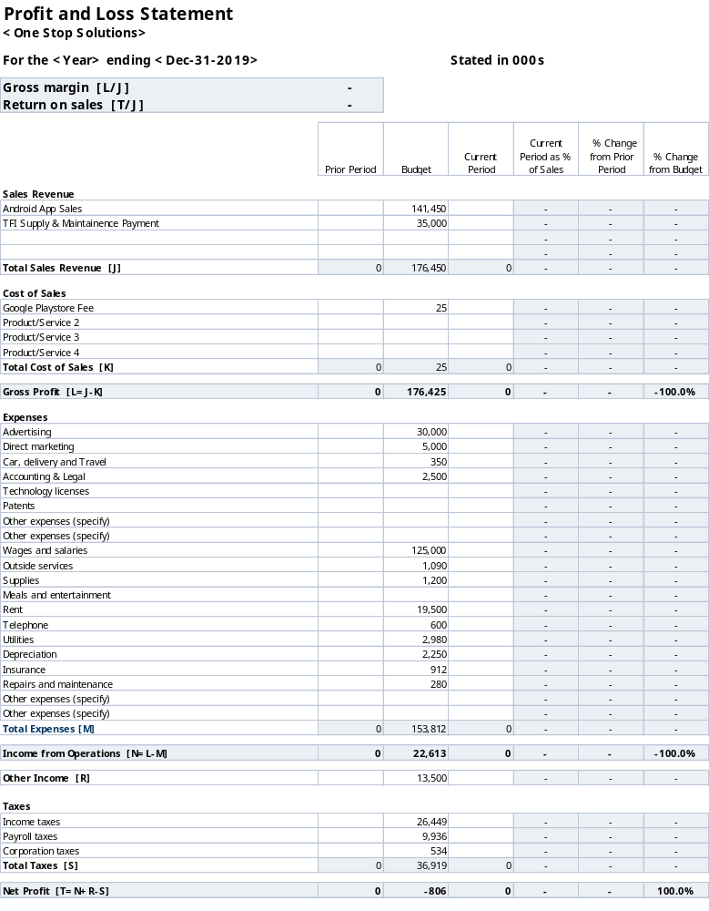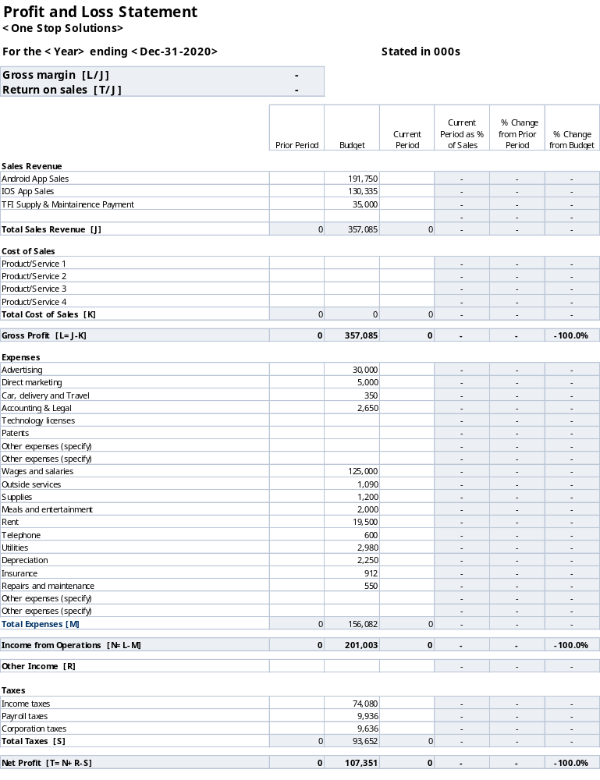
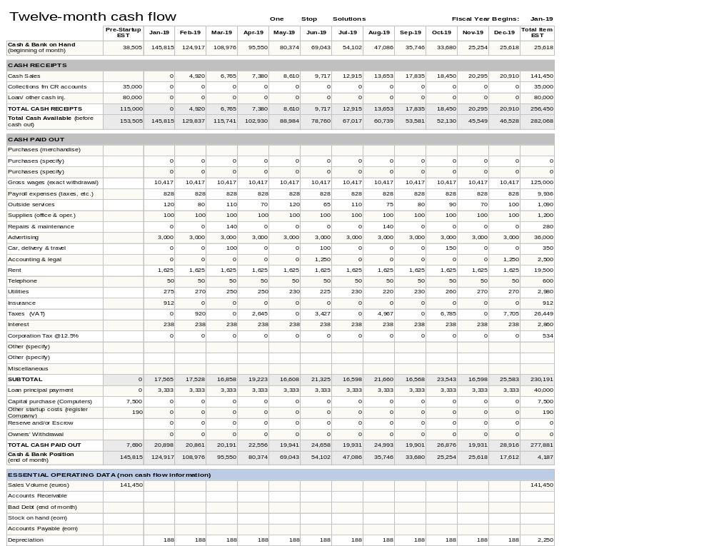

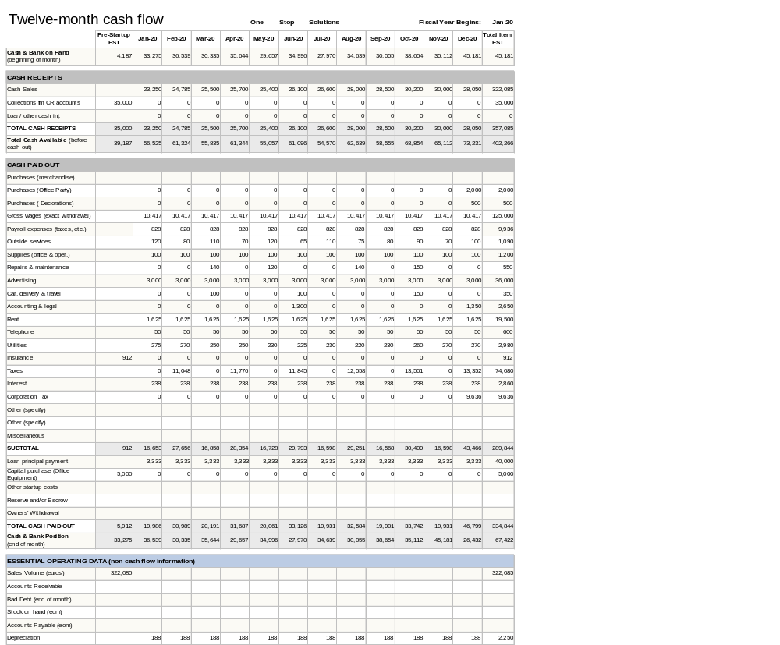
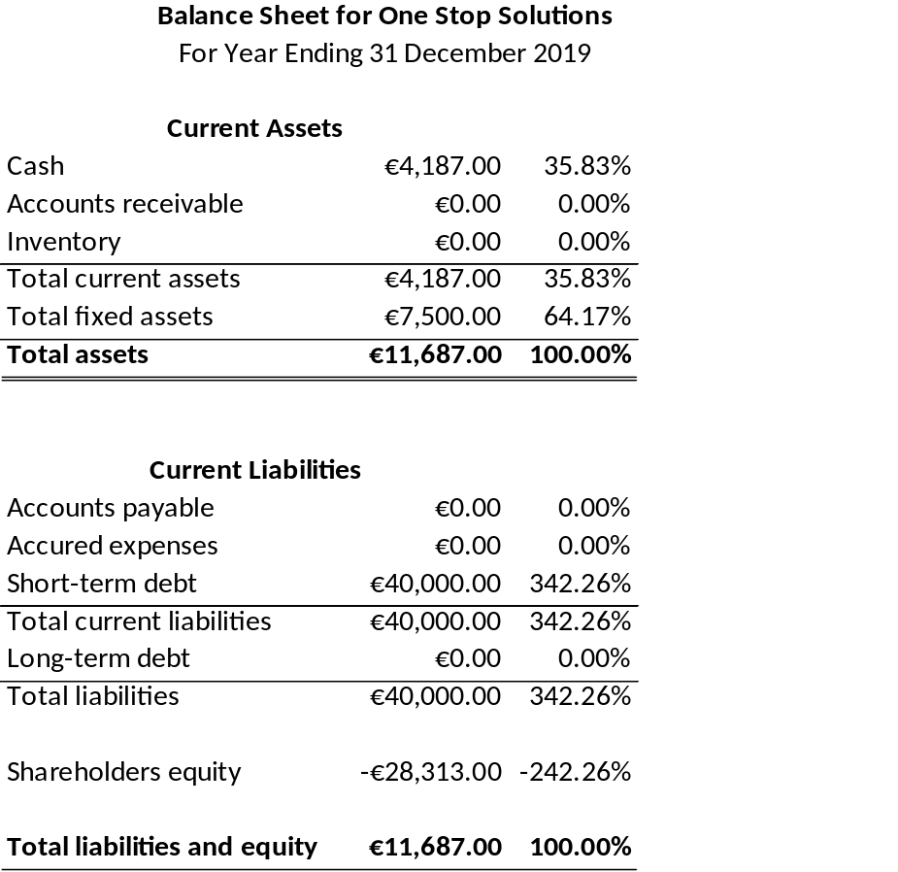

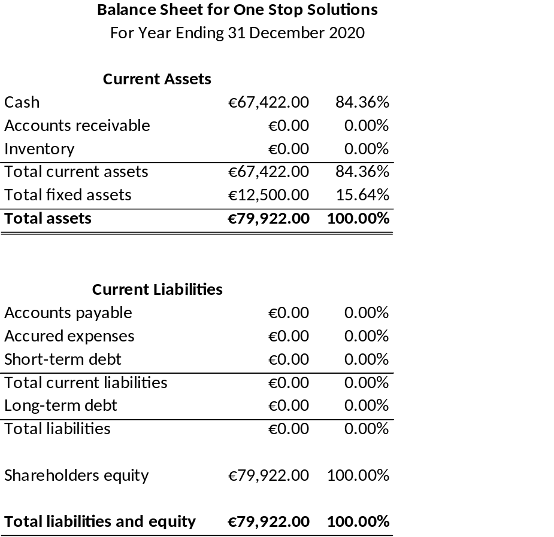

Appendix D Promoters’ C.V’s.

Muhammad Abu Bakar Sani
DATE OF BIRTH: 23/02/1999
CONTACT NO: 0899757444
EMAIL: abubakargill538@gmail.com
ADDRESS: 32 A Manor Road, Palmerstown, Dublin20

PROFILE/SKILLS

- Hard working
- Highly motivated to learn new things
- Good user of MS word, Excel, PowerPoint, Project and Access.
- Good in POS software's (QuickBooks, Sage)
- Good communicator
- Good knowledge of Linux
- Good knowledge of HTML, CSS, PHP, MySQL, Json, JavaScript, xml and Java.
- Good knowledge of organic and inorganic chemistry, Chemical equation balance and chemical reactions between Acids and bases
- Good in Mathematics

Education
Saha Group of College
Fsc Pre Engineering
English, Physics, Chemistry, and Mathematics

Divisional Model College
Matric
English, Physics, Chemistry, Biology and Mathematics

IELTS (6 Bands)
English Listening, reading, speaking and writing

National College of Ireland
BSc (Honours) in Computing
Web Design * Computing Industry * Problem Solving * Introduction to Mathematics * Managing your learning * Operating System * Computer Architecture * Introduction to Programming * Software Application of Business * Digital Multimedia * Object Oriented Programming * IT Project Management * Introduction to Databases(MySQL workbench) * Web Application Development * Fundamentals Business Analysis * Software Engineering * Data Structure * Data Communication & Networking * Business Entrepreneurship * Interdisciplinary Team Project(Android Studio)

UCD
BA in Business
Learning to Learn * IT Skills for Business * Business Management 1 * Fundamentals of Finance * Business Maths * Business Communications * Small Business Development * Introduction to Business Law * Financial Accounting * Business Management 2 * Enterprise, Innovation and Planning * Market Research Practice * Employability Skills * Principles of Economics * Principles of Marketing

EMPLOYMENT HISTORY

Teaching (June 2016 – August 2016) Home Tutor

Responsibilities:

- Preparing students for their final Exams by setting revision classes
- Teaching MATHMATICS and PHYSICS to secondary students
- Enhancing their learning skills
- Improving their learning skills and mental level by explaining lecture in very convenient way and give them tasks to find and write in their own words with their own views.

Spar Assistant Manager (Volunteer)
The Courtyard, Fonthill Business Park, Clondalkin, Dublin

Responsibilities:

- Good customers dealing.
- Know how to use till.
- Good knowledge about variety of Grocery items.
- Stock Orders/Stock Maintenance
- Feedback and communication with Buyers
- To organize and maintain stockroom and shop floor in a systematic order to maximize business efficiency
- To make Sales/Purchase Invoices by using POS (QuickBooks and Sage)
- To Organize sales in shop
- To support and assist with regular training programs of every member of the team
- Good team worker
- Know how to convince customers to buy products from shop
- Good knowledge of how to do pricing and make profits

Hobbies and interests
- Like to make Java Applications.
- Like to make Web Sites for Small businesses
- Reading books: love to read Chemistry Books, novels and funny comics.
- Online information: like to know about new Cars and their specification’s and Mobile phones specially Samsung.
- Like to collect coins of all currencies.

UMER IQBAL
3A RAINSFORD AVENUE DUBLIN 8
Tel: 0899891497
Email: umeriqbal0101@gmail.com

Profile.
- Practical experience developing software, web and business projects in team environment.
- Experience in using multiple software and IDEs such as NetBeans, Android Studio, MySQL Command Line, MySQL Workbench, Adobe fireworks, Adobe flash player, Text Pad, Notepad++, Microsoft Office.
- Strong Java (Object Oriented programming, data structure, android app), MySQL, (JavaScript, HTML5, CSS, XML, PHP etc) interpersonal and presentation skills.

Key Skills:
- Leaderships ability
- Communication and Interpersonal
- Teamworking
- A logical approach to problem solving
- Quick learning
- Confident decision making
- Presentation skills
- Customer service skills

Education:
- MSc in Software Development National College of Ireland (2017-2018)
- BSc (HONS) in computing National College of Ireland (2013-2017)
- Higher Secondary Certificate Punjab College Daska (2011-2013)
- Secondary School Certificate Govt High School Daska (2009-2011)

Experience
More than 5 years’ experience in software developer (Researching, designing, implementing and managing software programs. Testing and evaluating new programs).
Experienced in complex SQL Query writing and PHP code writing.
Experience in unit testing and bug fixing.
Good communication and interpersonal skills with good analytic power.

Working in SAR Security 2018 to 2019 (Current)
Position: Retail Security Officer
Responsibility:
A Retail Security Officer primary role is Loss Prevention and Asset Protection. The Retail Security Officer works actively together with the store manager to prevent theft by the customers and also from staff. A common control is to check staff when leaving work and also check when products are delivered to the store.

Hobbies and Activities
Reading books As I love reading books
Other Cricket, and going to gym

Jason Smith
27 Dunmore Avenue, Artane, Santry, Dublin 9
Tel: 085-0070070
Email: Jason.smith.74@ost.ie

A competent team leader with ability to meet deadlines and work under pressure. Enthusiastic with a positive attitude and excellent attention to detail.
Key Skills

- Highly motivated towards achieving goals
- Self-motivated with good decision making skills.
- Adaptable with flexability to work in various roles
- Strong organizational and time management skills
- Good interpersonal and people skills, ability to work independently or as part of a team
Computer Skills

A skilled graphic designer with over ten years’ experience. Advanced in Adobe applications Adobe Photoshop, Adobe Illustrator, Microsoft Office applications, Libre Office applications, Html, CSS, Javascript.

Employment

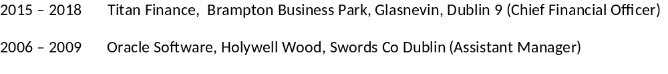Education

2011 – 2015 National College of Ireland
BSc (Honours) in Computing
2005 – 2009 Dublin Business School, 13/14 Aungier Street, Dublin, Ireland
BA (Hons) Accounting & Finance

Hobbies and Interests

Football, Reading, Chess, Music
References
I will gladly provide the details of referees on request

Curriculum Vitae - Mark O’Kelly
Personal Summary
A passionate leader with excellent communication skills and a very successful management record. I am very highly educated, with relevant qualifications. I am a motivational manager with great inter-personal skills with the capacity and passion to realise the vision of any company I manage. I possess CEO experience and I will ensure that company objectives and expectations are delivered and maintained.

Work Experience
Operations Manager, One Stop Travel App, 09/2018 – current
- Coordinating with Departments: Production, Finance and Marketing.
- Ensuring efficiency by communication with employees.
- Maintaining equipment and update software (Android Studios, MS Office)
- Negotiating contracts with outside parties
- Part of the founding team - established the strategy and branding for this regional effort to catalyse growth in the difficult position as a start-up

Executive Personal Assistant to Board of Directors in Bus Eireann 11/2013 – 09/2018
- Follow agency guidelines and customer specifications in projects
- I oversaw a training program in social media strategy for the company: I have created 100s of PowerPoint presentations; authored scores of newsletters and grew social media communities.
- Led efforts to develop a fully integrated, marketing communications plan and team, growing team from two to five members

Research Assistant in Bus Eireann Marketing Department, 05/2010 – 10/2013
- Researching social Trends and Matching company’s Marketing strategy.
- Pioneered a blueprint for innovation regarding new social media platforms (Instagram, snapchat and twitch)
- Integrated social media platforms to the existing online presence.
- Collaborate in team environment to complete copywriting tasks and meet project milestones.
- Coordinated with other departments customer engagement to build and sustain market presence.

Academic Qualifications
- National College of Ireland 2005 – 2009
BSCH Computing
- Maynooth University 2009 – 2011
MSc Computing (Social Media Marketing)
- Institute of Technology Tallaght 2011 – 2013
MSc Computing (Agile Analysis & Project Management)
- Dublin Institute of Technology 2013 - 2018
PhD Computing (Advanced Software Development)

References – Available on request

Appendix F Typical Product Drawings.

